0. Install NiDaqmx 9.0.2 driver with .NET 3.5 support.
1. Open ClassLibrary1.sln in C# 2008 Express Edition.
2. Click Properties/Build Events. Change Post Build Event command line with your letters of drives with your Program Files folder and Windows folder. In my case both letters is C:\
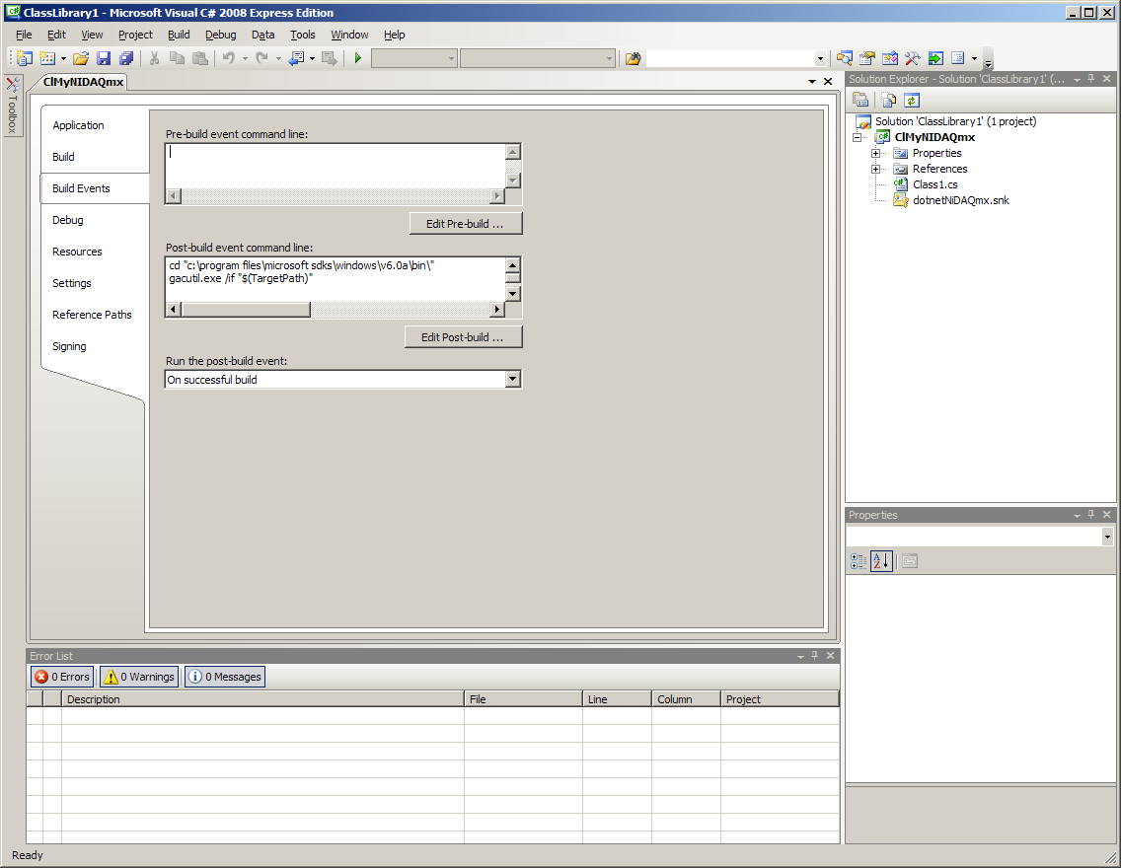
3. Press F6 or click Build/Build Solution. You can see something like this:
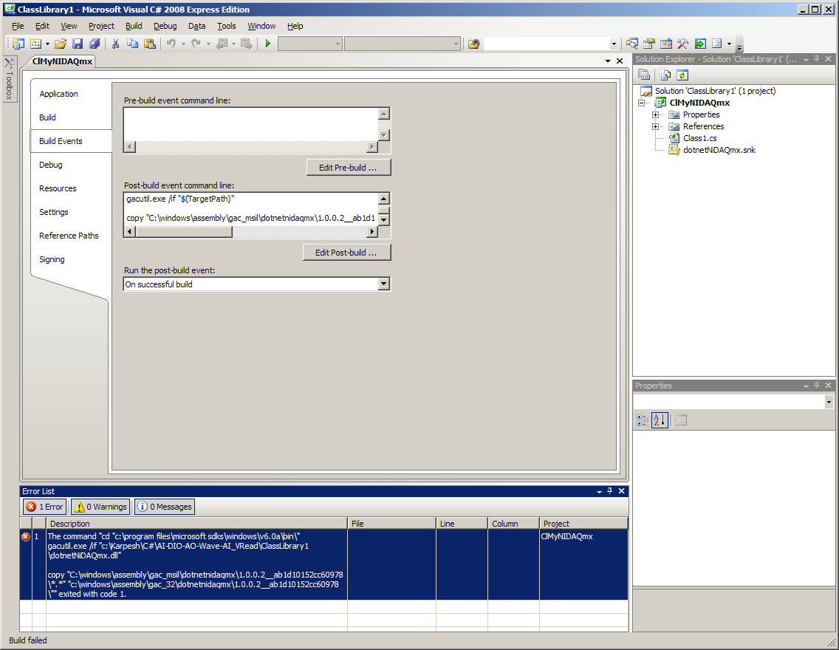
It’s ok. Then copy manually
c:\WINDOWS\assembly\GAC_MSIL\dotnetNiDAQmx\1.0.0.2__ab1d10152cc60978\dotnetNiDAQmx.dll
to
c:\WINDOWS\assembly\GAC_32\dotnetNiDAQmx\1.0.0.2__ab1d10152cc60978\
This is not necessary when you distribute your Delphi application, but Delphi 2009 search assemblies only in GAC_32, not in GAC_MSIL. It is strange, but it is the fact :)
Press F6 or click Build/Build Solution in C# again:
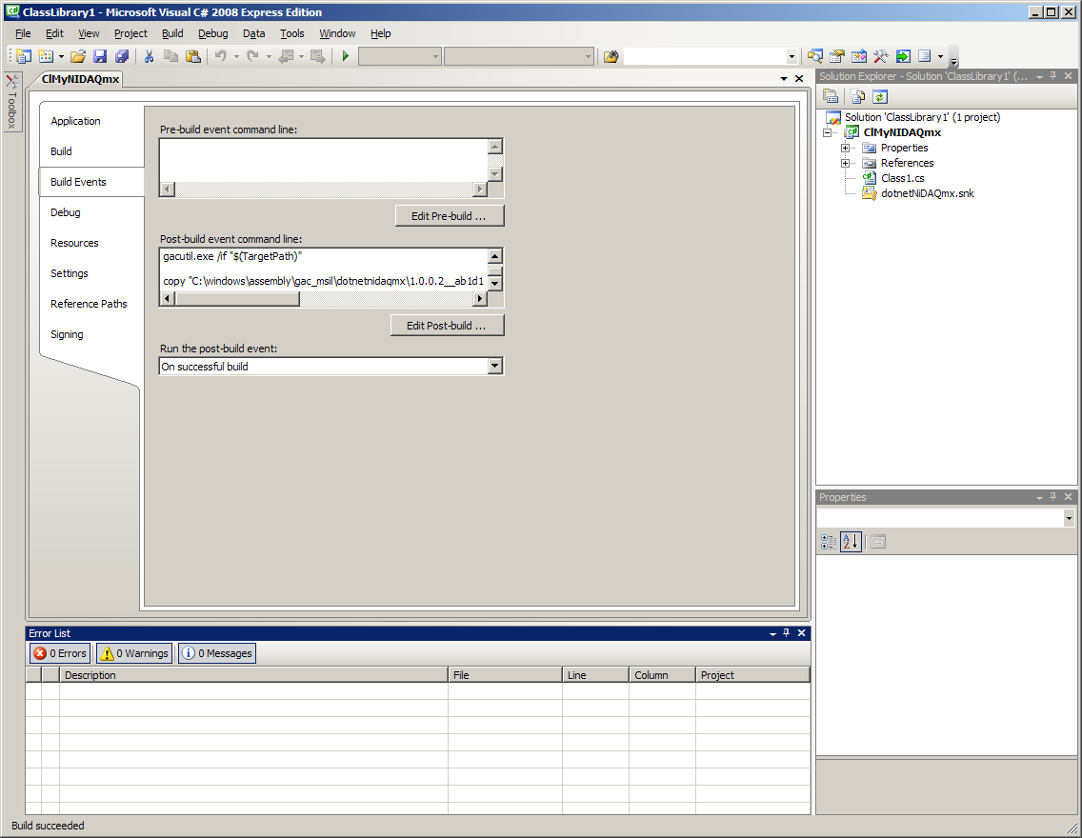
There are no any errors now.
4. Start Delphi 2009. Click Component/Import Component. Select Import .NET Assembly, click Next. Enter first letters of dotnetnidaqmx.dll to reduce waiting time. Click Next.
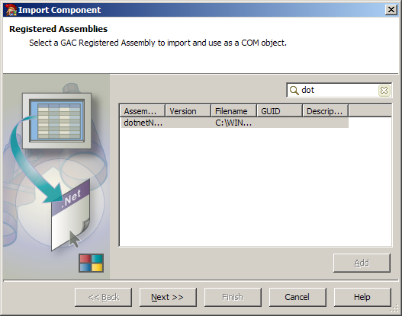
5. Select Generate Components Wrappers. Click Next.
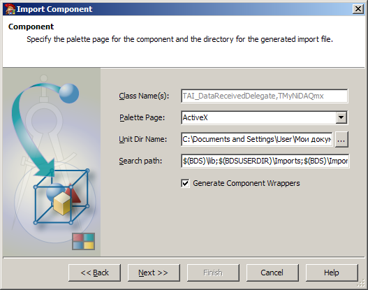
6. Select Install to New Package. Click Next
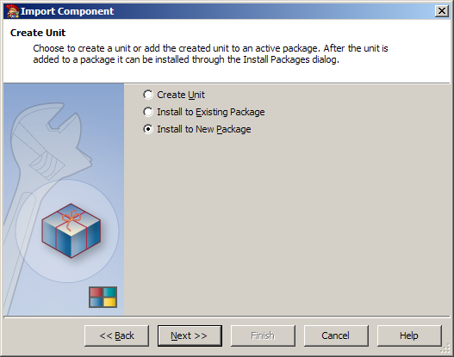
7. Select Package Name. Click Finish
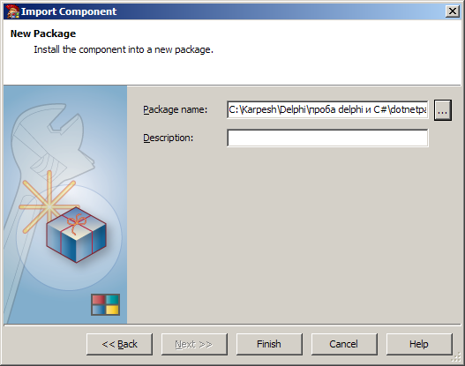
8. You will receive the message like this:
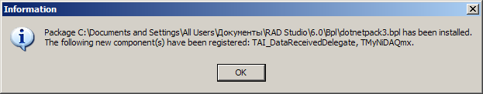
It’s great. Now you can use your component TMyNiDAQmx.

(Delphi has a bug here. If after appearing this message Delphi not responding, close and reopen it. In ActiveX palette there are two new components. If there are not, open your created package (for example dotnetpack3.dproj) and select Compile/Install).
9. Open Delphi example (Project1.dproj). If all works well you can see (after pressing buttons):
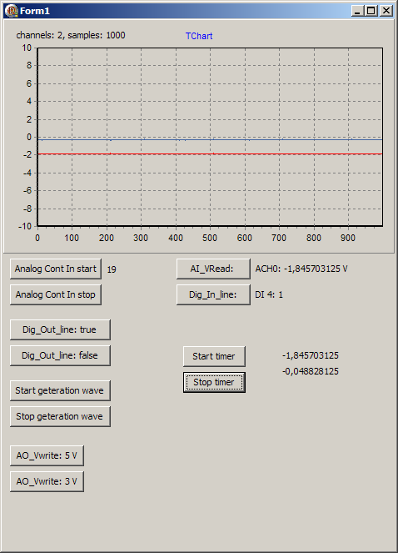
10. To distribute your application you must copy to client’s computer your .exe file, dotnetNiDAQmx.dll and register assembly dotnetNiDAQmx.dll for com interop. All modern install programs can do it (InstallAware, InstallShield and so on). Client’s computer must have installed .NET 3.5. (if not, you can do it by install program too) and NiDaqmx 9.0.2.
You can also register your assembly in Global Assembly Cash (GAC) (it not necessary, but suitable if you have many applications working with one assembly).

